ASSIGNMENT 3 – CO3
C++
Name: C. Pavani
Register Number: 192524260
Total Marks: 100
Title: Constructors, Destructors and Operator Overloading in C++
GitHub Repository Link: https://github.com/cchillapavani-arch/DSA0120-C-192524260-assignments

Q1 – Constructors and Constructor Overloading
Aim: Create Book objects using default, parameterised and overloaded constructors and validate the number of copies.

Answer:
A constructor runs automatically when an object is created. Constructor overloading means defining constructors with different parameter lists. Member initializer lists initialize members directly, and constructor delegation avoids repeating initialization code.

C++ Program:
#include <iostream>
#include <string>
using namespace std;
class Book {
string title; int copies;
public:
Book() : Book("Unknown", 0) {}
Book(string t) : Book(t, 1) {}
Book(string t, int c) : title(t), copies(c < 0 ? 0 : c) {}
void display() const { cout << "Title: " << title << ", Copies: " << copies << endl; }
};
int main() {
Book b1; Book b2("C++ Basics"); Book b3("Data Structures", 5); Book b4("Invalid Book", -3);
b1.display(); b2.display(); b3.display(); b4.display();
}

Output:
Title: Unknown, Copies: 0
Title: C++ Basics, Copies: 1
Title: Data Structures, Copies: 5
Title: Invalid Book, Copies: 0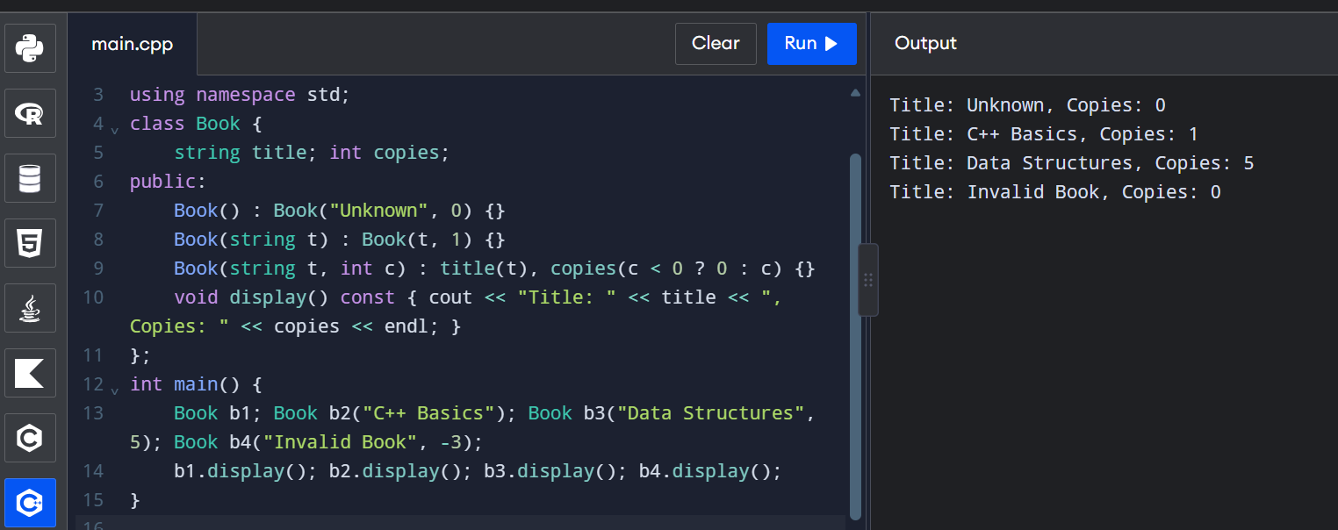Design and Analysis:
- The compiler supplies a default constructor only when no constructor is declared. If a constructor is declared, the compiler does not automatically add a zero-argument constructor.
- Initializer lists initialize members directly; they are necessary for const members and references and avoid default construction followed by assignment.
- Members initialize in their class declaration order, not the order written in the initializer list.
- Object states: b1=(Unknown,0), b2=(C++ Basics,1), b3=(Data Structures,5). A negative count is changed to zero.
- Use explicit on a one-argument constructor to prevent unwanted implicit conversion. Book b("C++") works; Book b = "C++" is rejected when the constructor is explicit.

Experimental Investigation:
- Removing the default constructor makes Book arr[2]; fail if no zero-argument constructor is available.
- To see -Wreorder, deliberately list initializers in an order different from member declaration order and compile with -Wall -Wextra; initialization still follows declaration order.
- The negative-copy test confirms that the object never stores a negative count.

Alternative Concept and Complexity Analysis:
One constructor with defaults, Book(string t="Unknown", int c=0), can handle all cases. Object creation is O(1) time and O(1) space in either design. Overloads make each creation situation clearer; delegation keeps validation in one place.
Result: Book objects are created safely using overloaded constructors, initializer lists and constructor delegation.

Q2 – Copy Constructors: Shallow and Deep Copies
Aim: Implement deep copying for a Prescription class that stores a dynamically allocated array of medicine names.

Answer:
A shallow copy copies only the pointer address, so objects share one array and may double-delete it. A deep copy allocates a separate array and copies every element. The Rule of Three says a class that manages dynamic memory generally needs a destructor, copy constructor and copy assignment operator.

C++ Program:
#include <iostream>
#include <string>
using namespace std;
class Prescription {
int n; string* medicines;
public:
explicit Prescription(int count) : n(count), medicines(new string[count]) {}
Prescription(const Prescription& o) : n(o.n), medicines(new string[o.n]) {
for (int i=0;i<n;++i) medicines[i]=o.medicines[i];
}
Prescription& operator=(const Prescription& o) {
if (this != &o) {
string* temp=new string[o.n];
for (int i=0;i<o.n;++i) temp[i]=o.medicines[i];
delete[] medicines; medicines=temp; n=o.n;
}
return *this;
}
~Prescription() { delete[] medicines; }
void set(int i,const string& m) { if(i>=0 && i<n) medicines[i]=m; }
string get(int i) const { return (i>=0 && i<n)?medicines[i]:""; }
};
int main() {
Prescription p(2); p.set(0,"Paracetamol"); p.set(1,"ORS");
Prescription q=p; q.set(1,"Cetirizine");
Prescription r(1); r=p; p.set(0,"Ibuprofen");
cout<<p.get(0)<<' '<<p.get(1)<<" | "<<q.get(0)<<' '<<q.get(1)
<<" | "<<r.get(0)<<' '<<r.get(1)<<endl;
}

Output:
Ibuprofen ORS | Paracetamol Cetirizine | Paracetamol ORS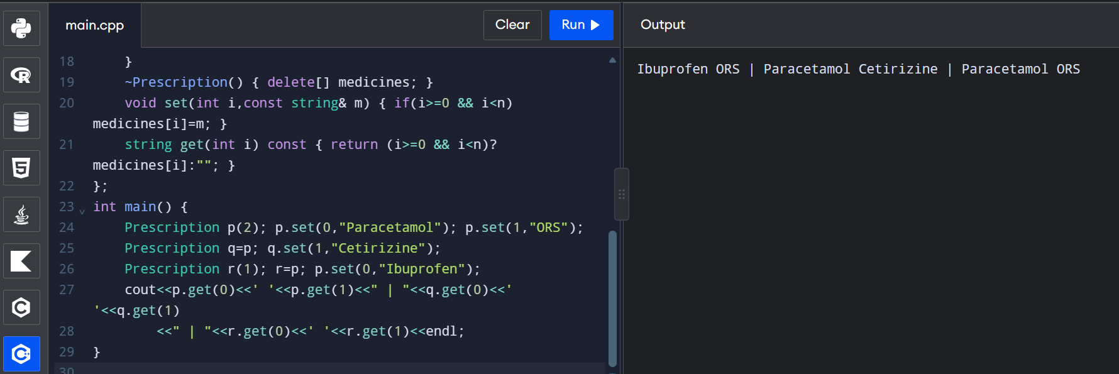

Design and Analysis:
- Shallow-copy memory: p and q point to the same array. A change through one object affects the other; both destructors may try to delete the same memory.
- Deep-copy memory: p and q own different arrays, so changes are independent.
- The copy constructor is used when initializing from another object, passing an object by value, and returning an object by value when copy elision does not remove the copy.
- Passing by const reference does not copy the object; passing by value normally does.

Experimental Investigation:
- Add a message in the copy constructor to count copies. A pass-by-value function creates a copy; a const-reference function does not.
- Copying n medicine names takes O(n) time and O(n) additional space.
- Self-assignment p=p is safe because the assignment operator checks this != &o.
- Compile with g++ -std=c++17 -fsanitize=address -g program.cpp -o program. The deep-copy version should finish without double-free or use-after-free errors. The shallow-copy version can report a memory error.

Alternative Concept and Complexity Analysis:
Replacing the raw array with vector<string> lets the compiler-generated copy operations make independent copies (Rule of Zero). Deep copy takes O(n) time and O(n) extra space; shallow pointer copying is O(1) but unsafe for independent ownership.
Result: The deep-copy constructor, assignment operator and destructor make prescription objects independent and prevent double deletion.

Q3 – Dynamic Constructors and Destructors
Aim: Allocate a two-dimensional auditorium seat map dynamically and release all memory when an event object is destroyed.

Answer:
A dynamic constructor allocates memory during object creation using new. A destructor runs automatically when an object's lifetime ends and releases resources using delete or delete[].

C++ Program:
#include <iostream>
using namespace std;
class Event {
int rows,seats; char** map;
public:
Event(int r,int s):rows(r<0?0:r),seats(s<0?0:s),map(nullptr) {
if(rows>0 && seats>0) {
map=new char*[rows];
for(int i=0;i<rows;++i) { map[i]=new char[seats];
for(int j=0;j<seats;++j) map[i][j]='O'; }
}
cout<<"Event created: "<<rows<<" rows"<<endl;
}
void book(int r,int s) {
if(r>=0 && r<rows && s>=0 && s<seats && map[r][s]=='O') {
map[r][s]='X'; cout<<"Seat booked"<<endl;
} else cout<<"Invalid or unavailable seat"<<endl;
}
void cancel(int r,int s) {
if(r>=0 && r<rows && s>=0 && s<seats && map[r][s]=='X') {
map[r][s]='O'; cout<<"Booking cancelled"<<endl;
} else cout<<"No booking to cancel"<<endl;
}
~Event() {
if(map) { for(int i=0;i<rows;++i) delete[] map[i]; delete[] map; }
cout<<"Event closed; memory released"<<endl;
}
};
int main() {
Event local(2,3); local.book(0,1); local.cancel(0,1);
{ Event blockEvent(1,2); blockEvent.book(0,0); }
Event* heapEvent=new Event(2,2); heapEvent->book(1,1); delete heapEvent;
}

Output:
Event created: 2 rows
Seat booked
Booking cancelled
Event created: 1 rows
Seat booked
Event closed; memory released
Event created: 2 rows
Seat booked
Event closed; memory released
Event closed; memory released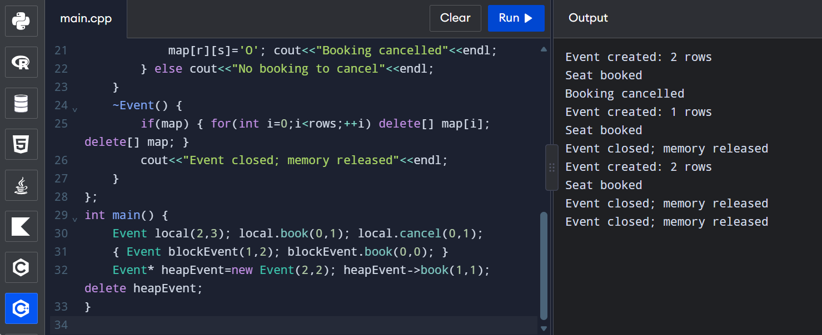

Design and Analysis:
- Local objects are destroyed automatically at the end of their scope. A block-scope object is destroyed at the closing brace. A heap object is destroyed only when delete is used.
- Use delete[] for memory allocated with new[]. Using delete instead of delete[] is undefined behaviour. Forgetting delete causes a memory leak.
- A destructor has no return type or arguments and cannot be overloaded.
- Memory layout: map points to an array of row pointers; each row pointer points to its own character array.

Experimental Investigation:
- Constructor/destructor messages show the block object closes first, then the heap object when delete is called, and finally the local object at the end of main.
- Run with -fsanitize=address. The correct program releases each row and then the row-pointer array.
- Seat data sizes: 10×20 = 200 bytes; 100×200 = 20,000 bytes; 1,000×2,000 = 2,000,000 bytes, excluding row pointers and allocator overhead.
- Zero rows allocate no seat map and are safely destroyed.

Alternative Concept and Complexity Analysis:
A contiguous rows×seats block needs one allocation and can be indexed by r*seats+s. The row-pointer design uses rows+1 allocations and extra pointer storage. Access is O(1) in either design. vector<vector<char>> is another safe option.
Result: The Event class dynamically manages seats and releases all allocated memory in its destructor.

Q4 – Overloading Arithmetic and Stream Operators
Aim: Create a Money class that stores amounts in paise and supports arithmetic, comparison and stream operators.

Answer:
Operator overloading gives familiar operators a meaning for user-defined classes. Storing money as integer paise avoids many floating-point rounding problems.

C++ Program:
#include <iomanip>
#include <iostream>
using namespace std;
class Money {
long long paise;
public:
Money(long long r=0,int p=0):paise(r*100+p) {}
Money operator+(const Money& m) const { return Money(0,static_cast<int>(paise+m.paise)); }
bool operator==(const Money& m) const { return paise==m.paise; }
friend ostream& operator<<(ostream& out,const Money& m) {
long long v=m.paise;
if(v<0) { v=-v; out<<"-Rs "; } else out<<"Rs ";
out<<v/100<<'.'<<setw(2)<<setfill('0')<<v%100<<setfill(' ');
return out;
}
};
int main() {
Money a(120,75),b(79,25); Money c=a+b;
cout<<c<<endl<<boolalpha<<(c==Money(200))<<endl;
Money x(0,75),y(0,50); cout<<"Carry test: "<<x+y<<endl;
}

Output:
Rs 200.00
true
Carry test: Rs 1.25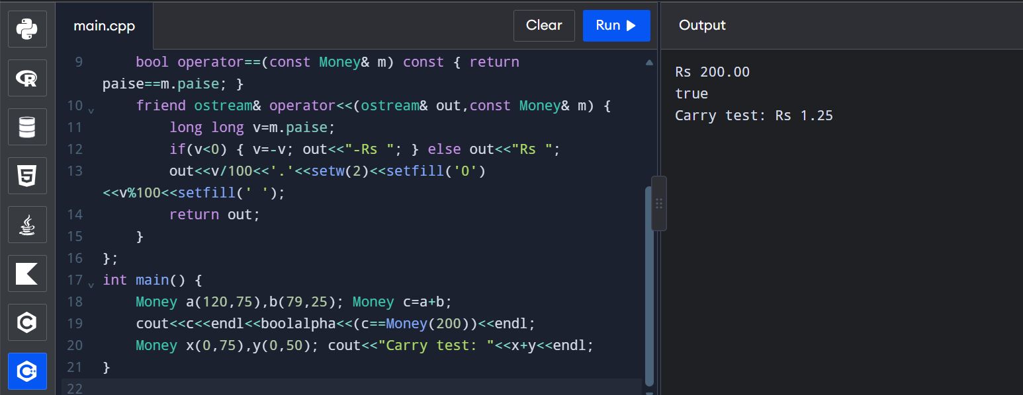

Design and Analysis:
- + returns a new object because it calculates a result without changing operands. += changes the left operand and normally returns Money& (*this), allowing chaining.
- + and == can be member functions. << is a friend non-member because its left operand is ostream, not Money.
- The expression a+b is translated to a.operator+(b) when + is a member.
- A full Money class can also define -, +=, < and >>. Stream operators return stream references for chaining.

Experimental Investigation:
- Rs 0.75 + Rs 0.50 gives Rs 1.25, showing paise carry into rupees.
- Negative subtraction can be allowed and printed with a minus sign, or rejected according to the billing requirements.
- Operator-based code such as total=item1+item2 is usually clearer than add(item1,item2).
- Integer paise represents currency exactly to the nearest paise; double can introduce binary floating-point rounding.

Alternative Concept and Complexity Analysis:
Multiplying one Money amount by another is usually not meaningful; multiplying Money by a quantity or rate can be useful. Each operation takes O(1) time and O(1) extra space. A non-member friend + can support both 100+m and m+100 when suitable conversions are allowed.
Result: The Money class performs arithmetic and printing using overloaded operators and stores the amount in integer paise.

Q5 – Overloading Increment, Comparison and Subscript Operators
Aim: Overload prefix and postfix increment, comparison and subscript operators for Time and Playlist classes.

Answer:
Prefix increment changes the object and returns a reference. Postfix increment has a dummy int parameter to distinguish it and returns the old value as a copy.

C++ Program:
#include <iostream>
#include <stdexcept>
#include <string>
#include <vector>
using namespace std;
class Time {
int seconds;
public:
explicit Time(int s=0):seconds(s<0?0:s) {}
Time& operator++(){ ++seconds; return *this; }
Time operator++(int){ Time old=*this; ++seconds; return old; }
bool operator==(const Time& t) const{return seconds==t.seconds;}
bool operator<(const Time& t) const{return seconds<t.seconds;}
void display() const { cout<<seconds/3600<<':'<<(seconds/60)%60<<':'<<seconds%60; }
};
class Playlist {
vector<string> tracks;
public:
Playlist(initializer_list<string> x):tracks(x){}
string& operator[](int i) {
if(i<0 || i>=static_cast<int>(tracks.size())) throw out_of_range("Playlist index out of range");
return tracks[i];
}
const string& operator[](int i) const {
if(i<0 || i>=static_cast<int>(tracks.size())) throw out_of_range("Playlist index out of range");
return tracks[i];
}
};
int main(){
Time t(5); Time a=t++; Time b=++t;
cout<<"a = "; a.display(); cout<<"\nb = "; b.display(); cout<<"\nt = "; t.display(); cout<<endl;
Playlist p{"Song A","Song B"}; cout<<p[0]<<endl;
try{ cout<<p[2]<<endl; } catch(const out_of_range& e){ cout<<e.what()<<endl; }
}

Output:
a = 0:0:5
b = 0:0:7
t = 0:0:7
Song A
Playlist index out of range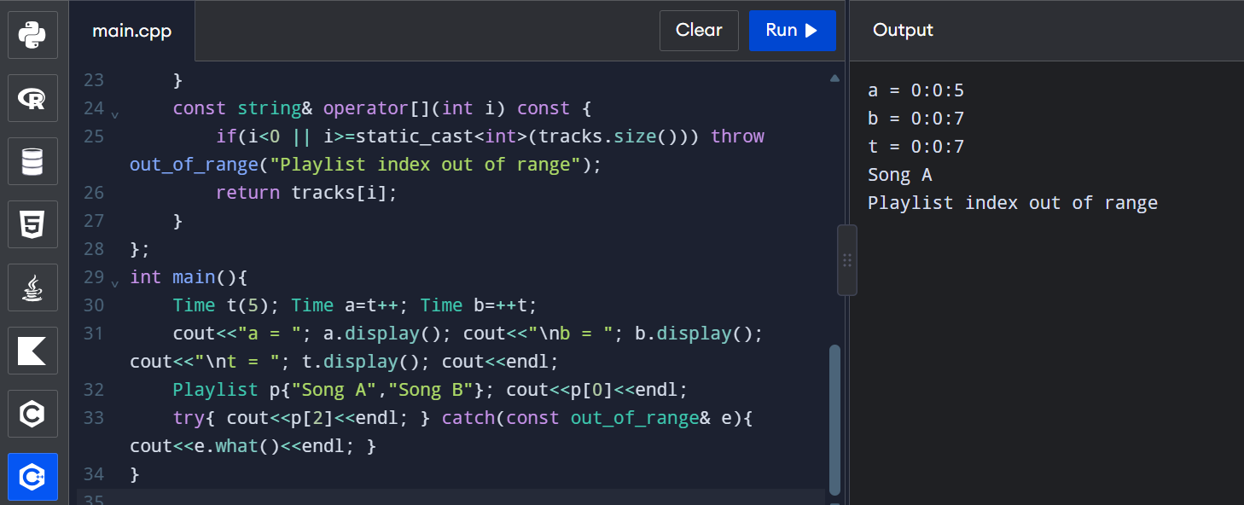

Design and Analysis:
- The compiler distinguishes postfix ++ by the dummy int parameter in operator++(int).
- Postfix returns a copy of the old object and may be slower. Prefix returns a reference and avoids that copy.
- Playlist has a non-const operator[] for modifying tracks and a const version for read-only objects.
- An invalid index should be reported safely, for example by throwing std::out_of_range.

Experimental Investigation:
- For c=5, a=c++ stores 5 and c becomes 6; b=++c stores 7 and c remains 7.
- Test negative and size indexes; both should throw out_of_range.
- 59:59 is 3,599 seconds; the next increment becomes 1:00:00.
- Measure 10,000,000 increments at -O0 and -O2 on your own compiler. Optimisation may make the timing difference very small.

Alternative Concept and Complexity Analysis:
An at(i) function conventionally throws out_of_range. Checked and unchecked access are both O(1); checked access adds a bounds comparison. Prefix is preferred for class types because it avoids returning an old-value copy.
Result: Prefix/postfix increments, comparisons and checked playlist indexing are demonstrated.

Q6 – The Rules of Operator Overloading
Aim: Implement a Text class using dynamic character memory and overload assignment, concatenation, comparison and output operators.

Answer:
A class that owns a dynamic character array must manage copying and destruction correctly. The Rule of Three includes a copy constructor, copy assignment operator and destructor.

C++ Program:
#include <cstring>
#include <iostream>
using namespace std;
class Text {
char* data;
public:
Text(const char* s=""){ data=new char[strlen(s)+1]; strcpy(data,s); }
Text(const Text& o){ data=new char[strlen(o.data)+1]; strcpy(data,o.data); }
Text& operator=(const Text& o){
if(this!=&o){ char* temp=new char[strlen(o.data)+1]; strcpy(temp,o.data);
delete[] data; data=temp; }
return *this;
}
~Text(){ delete[] data; }
Text operator+(const Text& o) const {
char* temp=new char[strlen(data)+strlen(o.data)+1];
strcpy(temp,data); strcat(temp,o.data); Text result(temp); delete[] temp; return result;
}
bool operator==(const Text& o) const{return strcmp(data,o.data)==0;}
bool operator!=(const Text& o) const{return !(*this==o);}
friend ostream& operator<<(ostream& out,const Text& t){out<<t.data; return out;}
};
int main(){
Text a("Hello "),b("Pavani"); Text c=a+b;
cout<<c<<endl<<boolalpha<<(c!=a)<<endl;
Text empty; cout<<"Empty: ["<<empty<<"]"<<endl;
c=c; cout<<"Self assignment: "<<c<<endl;
}

Output:
Hello Pavani
true
Empty: []
Self assignment: Hello Pavani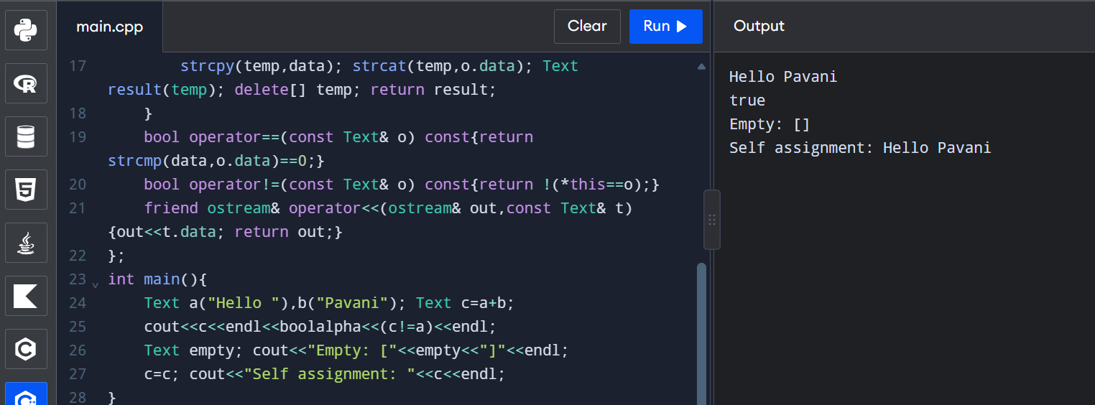

Design and Analysis:
- Operators that cannot be overloaded include ::, ., .*, ?: and sizeof.
- Overloading cannot change precedence, associativity or arity. At least one operand must be a user-defined type.
- operator= must be a non-static member function.
- A friend is useful when a non-member operator needs private access, such as ostream << Text.

Experimental Investigation:
- a+b+c is evaluated as (a+b)+c. Intermediate temporary objects may be created, though copy elision can remove some copies.
- Compile with -fsanitize=address to detect invalid memory use, leaks and double deletion.
- Compare with std::string for 100,000 concatenations. std::string is generally safer and more efficient because it manages memory.
- Self-assignment c=c is tested; the address check prevents deleting source data before copying.

Alternative Concept and Complexity Analysis:
std::string follows the Rule of Zero and avoids manual memory management. For lengths n1,n2,n3, left-to-right a+b+c copies about n1+n2 characters for the first result and n1+n2+n3 for the second. Temporary storage is proportional to the combined length. An append-based += approach can reduce some temporary allocations.
Result: The Text class safely supports deep copying, assignment, concatenation, comparison and printing.

Q7 – Design a Complex-Number Class from First Principles
Aim: To design a Complex class for calculating AC circuit impedance using constructors and overloaded operators.

Stage 1 – Interpret the Problem:
The data are the real and imaginary parts of impedance. Required operations are addition, subtraction, multiplication, division, equality, printing and magnitude. Constructors are needed for zero, a real value and real-plus-imaginary values.
- Store real and imaginary components as double values.
- Support series addition and parallel impedance calculation.
- Detect division by zero and report an error safely.

Stage 2 – Design:
For z1=a+bj and z2=c+dj:
- Addition: (a+c) + (b+d)j.
- Subtraction: (a-c) + (b-d)j.
- Multiplication: (ac-bd) + (ad+bc)j.
- Division: ((ac+bd)/(c²+d²)) + ((bc-ad)/(c²+d²))j.
- Magnitude: sqrt(a²+b²).

C++ Program:
#include <cmath>
#include <iostream>
#include <stdexcept>
using namespace std;
class Complex {
double real,imag;
public:
Complex():real(0),imag(0){}
Complex(double r):real(r),imag(0){}
Complex(double r,double i):real(r),imag(i){}
Complex operator+(const Complex& z)const{return Complex(real+z.real,imag+z.imag);}
Complex operator-(const Complex& z)const{return Complex(real-z.real,imag-z.imag);}
Complex operator*(const Complex& z)const{
return Complex(real*z.real-imag*z.imag,real*z.imag+imag*z.real);
}
Complex operator/(const Complex& z)const{
double d=z.real*z.real+z.imag*z.imag;
if(d==0.0) throw runtime_error("Division by zero impedance");
return Complex((real*z.real+imag*z.imag)/d,(imag*z.real-real*z.imag)/d);
}
bool operator==(const Complex& z)const{return real==z.real && imag==z.imag;}
double magnitude()const{return sqrt(real*real+imag*imag);}
friend ostream& operator<<(ostream& out,const Complex& z){
out<<z.real<<(z.imag>=0?" + ":" - ")<<(z.imag>=0?z.imag:-z.imag)<<"j"; return out;
}
};
int main(){
try{
Complex resistor(10,0),inductor(0,5),capacitor(0,-2);
Complex series=resistor+inductor+capacitor;
cout<<"Series impedance: "<<series<<endl;
cout<<"Magnitude: "<<series.magnitude()<<endl;
Complex z1(10,0),z2(0,10);
Complex parallel=(z1*z2)/(z1+z2);
cout<<"Parallel impedance: "<<parallel<<endl;
Complex zero; Complex test=z1/zero; cout<<test<<endl;
}catch(const exception& e){cout<<"Error: "<<e.what()<<endl;}
}

Sample Output:
Series impedance: 10 + 3j
Magnitude: 10.4403
Parallel impedance: 5 + 5j
Error: Division by zero impedance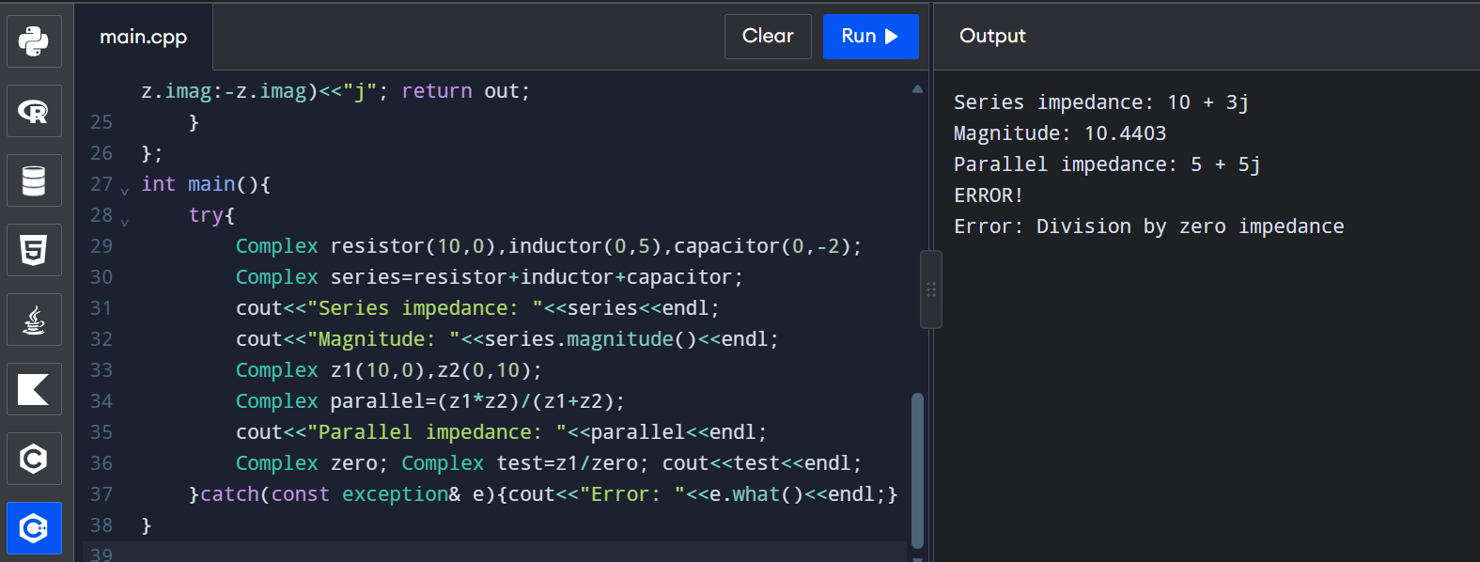

Stage 3 – Implement and Verify:
Series calculation: (10+0j)+(0+5j)+(0-2j)=10+3j. Magnitude = √(10²+3²)=√109≈10.4403. Parallel calculation: (10×10j)/(10+10j)=5+5j. Division by zero is caught and reported.

Stage 4 – Defend the Design:
- std::complex<double> already provides standard complex arithmetic and is preferred in normal applications.
- The custom class demonstrates constructors and operator overloading and allows a chosen division-by-zero policy.
- Each arithmetic operation takes O(1) time and O(1) space. Both designs store two double components.
- A limitation is exact floating-point equality; engineering applications may need a tolerance.

Alternative Concept and Complexity Analysis:
Using std::complex<double> would reduce the amount of code because its arithmetic operators are already implemented. Time per operation is O(1) and storage is two doubles in both designs. Division-by-zero handling still needs an application-level policy. Floating-point results may contain small rounding differences.
Result: The Complex class calculates series and parallel impedances, displays rectangular form and magnitude, and handles division by zero safely.

